Study Report from the Vietnam National University of Forestry
(Némethi Levente, Jakab András)
Introduction
This report summarizes our experiences and everything we learned during a one-month
exchange program at the Vietnam National University of Forestry (VNUF). Over the past
weeks, we had the unique opportunity to see firsthand how Vietnam successfully blends
traditional woodworking with modern, large-scale manufacturing. From designing furniture
with CAD/CAM software and learning about bamboo processing, to visiting local artisan
workshops, this journey was incredibly hands-on and eye-opening. The following sections
highlight our most important practical and academic takeaways from this month.
1
. Furniture Design and CAD/CAM Integration - Hien Nguyen Thi Thanh
The initial phase of the academic program was dedicated to modern furniture engineering,
emphasizing the integration of Computer-Aided Design (CAD) and Computer-Aided
Manufacturing (CAM) technologies. Practical training focused on structural 3D modeling
utilizing SketchUp software, complemented by advanced toolpath generation and CNC
programming using Vectric Aspire. These digital methodologies are essential in contemporary
wood processing for optimizing material yield and ensuring high-precision manufacturing.
During the practical sessions, comprehensive structural designs were developed for three
distinct cabinetry typologies. The first project involved the spatial planning, proportioning,
and structural detailing of a standard two-door wardrobe. This was followed by a more
complex architectural integration task: designing a six-door built-in storage unit, which
required precise spatial optimization and alignment calculations to meet interior architectural
constraints.
The last design assignment was a multifunctional, asymmetric cabinet configuration. This
complex unit was engineered to include three basal drawers, a primary full-length vertical
door, and two superior doors situated above the drawer section. These practical exercises
facilitated a deep understanding of digital modeling, component assembly detailing, and the
preparation of digital files for automated CNC machining processes within the wood industry.


2
. Material Science and Industrial Utilization of Bamboo - Phuoc Le ngoc
The curriculum also explored the structural properties and industrial processing of
Dendrocalamus barbatus (Luồng bamboo). While noted for its high density and thick walls,
raw bamboo presents natural physical limitations—such as a small diameter, a hollow stem,
and a large taper—which complicate direct utilization. To mitigate biological degradation,
targeted harvesting, borate impregnation, and rigorous kiln-drying are applied.
To overcome structural limitations, modern industrial utilization involves breaking bamboo
into elementary units and recomposing them via adhesives into large-scale, high-strength
panels. The primary manufacturing methodologies studied included:
•
•
•
•
Strip processing: Breaking the culm into flattened or sawn-shaved strips.
Sliver processing: Producing thin slivers to weave into mats or curtains.
Particle processing: Converting residues into particles or fibers for composite boards.
Composite processing: Integrating bamboo units with other materials (e.g., wood,
paper, plastics) to optimize integral properties. These principles were practically
observed in the manufacturing of Laminated Bamboo Panels (LBP), which involves
milling raw slats, starch-leaching via hydrothermal treatments, and high-pressure hot
pressing with low-VOC adhesives.
3
. The Vietnamese Wood Industry and Furniture Export - Hung Phan Duy
Vietnam has established a highly competitive furniture export sector driven by substantial
forestry resources and a skilled, cost-effective labor force. The nation's total forest area
reaches nearly 15 million hectares with a 42% cover rate, including 4.89 million hectares of
planted forests and 1.1 billion cubic meters of timber reserves. Despite this abundance,
domestic harvesting meets only 77.4% of the industry's demand, requiring 22.6% of timber to
be imported to sustain production. To address this deficit, the sector is aiming for self-reliance
while adopting foreign technological advancements to boost its $19 billion market capacity.
Furthermore, the industry benefits from a diligent population of over 100 million, where 69%
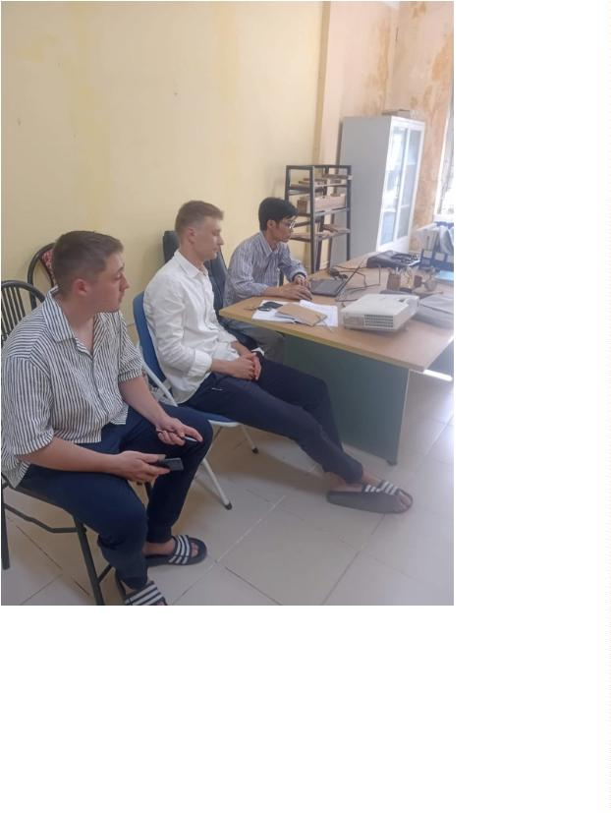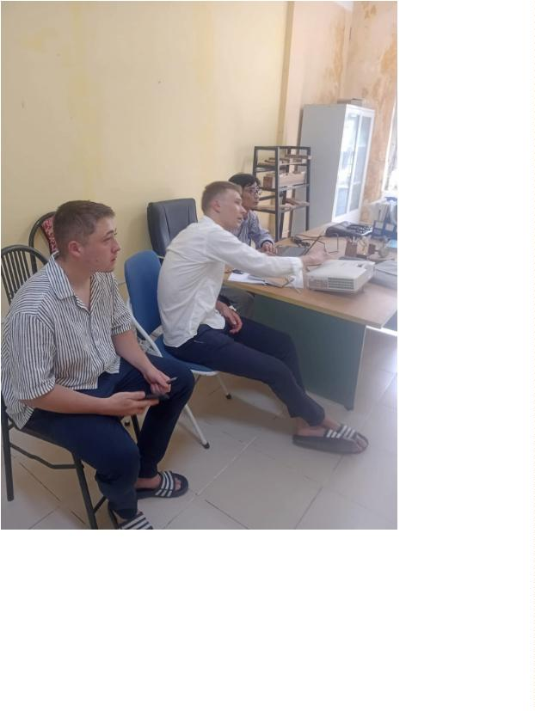

of the workforce possesses vocational training and 29.5% hold higher professional
qualifications. Labor costs remain highly competitive globally, averaging $250 to $350 per
month, which significantly bolsters export margins. This strategic resource management and
qualified workforce have propelled the industrial GDP contribution from 5% in 1986 to
2
4.5% in 2025, with a projected target of 28% by 2030.
4
. Growth Characteristics and Veneer Utilization of Fast-Growing Plantation
Species - Mai Trinh Hien
Recent research presented on fast-growing plantation species—specifically Acacia hybrid,
Acacia mangium, and Eucalyptus—highlighted their morphological development and
industrial processing characteristics. Studies on their growth dynamics indicate rapid cross-
sectional and height increments; however, stem cylindricity and form quality can vary
significantly. Notably, the Acacia hybrid generally exhibits superior cylindrical form and
straightness compared to pure A. mangium.ꢀUtilizing advanced hydrothermal pre-treatments
and rotary peeling technologies, they yield cost-effective, high-quality veneers that are
extensively processed into plywood and Engineered Timber Products (ETPs), thereby
ensuring a sustainable raw material supply for the sector.
5
. Vietnamese Timber Species and Their Architectural Applications - Nga
Hoang Thi Thuy
The timber utilized in the construction and furniture industries is primarily divided into two
main categories: high-strength natural hardwoods and sustainable plantation species.
•
Natural Hardwoods: Natural forests covering over 10.2 million hectares provide
highly durable timber with a density ranging from 0.7 to 1.2 g/cm³ and a service life
exceeding 100 years. Exceptionally heavy and load-bearing species such as Lim
(Ironwood), Táu, and Sến offer excellent termite resistance and are widely used for
traditional houses, temples, bridges, and heavy structural columns. Conversely, Gõ Đỏ
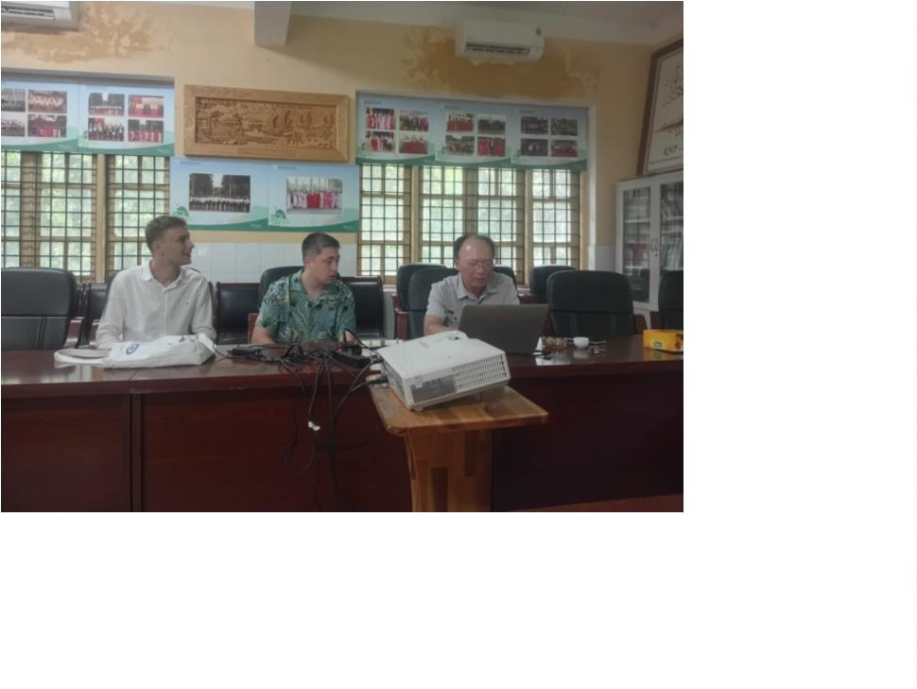

(Redwood) and Căm Xe (Burmese Rosewood) are celebrated for their attractive dense
grain and dimensional stability, dominating luxury interiors, premium furniture, and
flooring.
•
•
Plantation Timber: Covering approximately 4.7 to 5.0 million hectares, plantation
timber serves as the backbone of the modern wood industry. Teak wood, featuring a
high natural oil content, grants outstanding weather and moisture resistance, making it
an ideal material for outdoor decking and facades. Pine is a lightweight softwood
commonly chosen for interior ceilings and lightweight cabin architecture. Acacia and
Rubberwood provide an economical and sustainable source of raw materials for
interior finishes, furniture, and engineered wood panels (Plywood, MDF).
Bamboo and Engineered Timber Products (ETPs): Vietnam is home to over 200
bamboo species. Large-diameter species like Luồng and Tầm Vông are extensively
applied in constructing structural frames and pavilions due to their high strength-to-
weight ratio. The future of sustainable construction is heavily driven by the growth of
Engineered Timber Products (such as LVL, Glulam, CLT, and Bamboo Scrimber),
which provide large-span capabilities, high structural efficiency, and fast installation
for mass timber and modular buildings.
6
. Chemical Modification and Combustion Behavior of Fast-Growing Woods -
Tham Nguyen Thi
To address the low density, poor mechanical strength,
and high fire susceptibility of fast-growing plantation
woods like poplar (Populus adenopodaMaxim.) and
radiata pine (Pinus radiata Don.), chemical
modifications utilizing a combination of styrene-
acrylic copolymer (SAC) and sodium silicate (SS) are
applied. The combustion behavior and thermal
stability of these treated woods reveal several critical
industrial insights:
•
Ignition Resistance: Combined treatment with
SAC and SS significantly increases the
difficulty of ignition, resulting in a longer time
to ignition (TTI) and a higher limiting oxygen
index (LOI).
•
•
Structural Charring: Sodium silicate deposits
within the cell lumina (vessels and tracheids)
and forms a thermally insulating glassy
protective film, promoting increased residual char formation during pyrolysis.
Smoke and Toxicity Hazards: Despite the delayed flaming and increased ignition
difficulty, the overall fire risk is not mitigated. The incorporation of SS alongside SAC
ultimately leads to higher total heat release, dense smoke production, and elevated
carbon monoxide (CO) concentrations, which present an increased danger regarding
casualties in fire scenarios.
7
. Surface Finishing Materials and Panel Overlays - Hong Pham Thi Anh
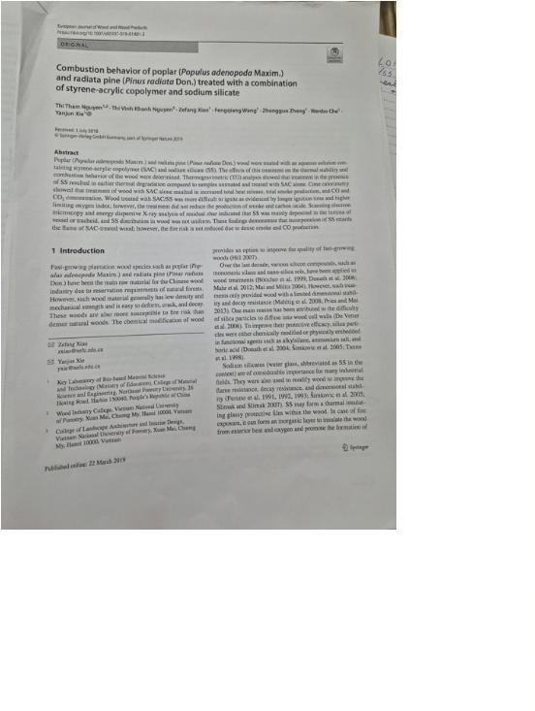

In the context of the global wood and furniture industry, the selection of appropriate surface
overlays is critical for balancing aesthetics, durability, and cost-efficiency. The primary
materials utilized include:
•
Wood Veneer: Extracted via slicing or peeling (0.2–
3.0 mm thickness), 100% natural wood veneers
(e.g., oak, ash, teak) offer eco-friendly aesthetics at
a lower cost than solid wood. However, they require
post-processing (oiling) and are susceptible to
moisture, heat, and mechanical damage, making
them suitable primarily for premium furniture and interior MDF/HDF applications.
Melamine Paper: Comprising decorative paper
impregnated with melamine resin (0.1–0.2 mm
•
•
thickness), this highly cost-effective material provides
versatile patterns for mass-produced cabinetry. Despite
its visual flexibility, it remains sensitive to moisture
and cannot be easily repaired.
Acrylic Panels (PMMA): Ranging from 0.7 to 1.4 mm
in thickness, these synthetic plastics offer premium, UV-resistant
high-gloss or matte finishes. Although expensive and prone to
fingerprints, their flawless glass-like effect makes them highly
desirable for modern kitchen cabinetry, requiring high-precision
equipment and PU adhesives for application onto HDF/MDF
substrates.
•
Laminated Panels (HPL/CPL): Constructed from multiple layers of
phenolic-impregnated kraft paper topped with melamine-
infused decorative overlays (typically 6 layers, 0.5–1.0 mm
thick). They provide exceptional mechanical, heat, and water
resistance, rendering them ideal for high-traffic countertops,
despite physical limitations in sharp-angle bending.
8
. Field Observations of Termite Wood Degradation - Phuong Tong Thi and
Loan Nguyen Thi
During our field excursions, we observed firsthand the devastating impact of termite colonies
on local timber. These insects completely hollow out standing tree trunks, reducing the solid
wood fibers into a spongy, reddish-brown, soil-like mass. Furthermore, this severe mechanical
degradation is often accompanied by secondary fungal infections, visible as white mycelial
growth on the decaying wood. Witnessing this structural collapse in natural environments
perfectly illustrated why the rigorous chemical preservation and modification treatments
discussed earlier are absolutely critical for tropical wood products.
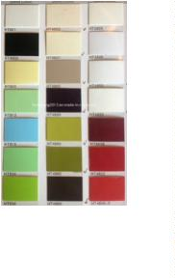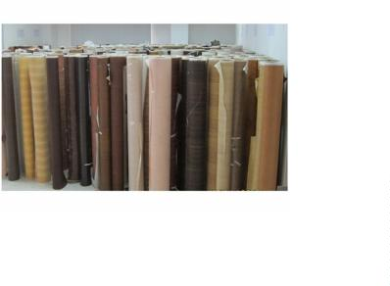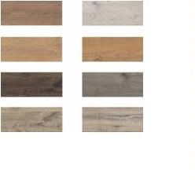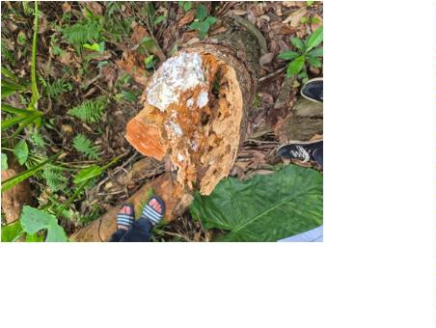

9
. Vacuum Press Technology and Surface Laminating - Dai Vu Huy
The session explored the operational principles of Programmable Logic Controller (PLC)
driven vacuum presses, which ensure uniform pressure distribution across complex
geometries. Specific applications were highlighted, including the precise veneering and
laminating of curved and concave surfaces, as well as the seamless application of colored
decorative foils over irregular 3D profiles. This presentation effectively demonstrated the
technology's critical role in modern custom furniture manufacturing and complex architectural
joinery.
1
0. Microscopic Wood Anatomy – Kien Nguyen Trong
As for the wood anatomy studying we used an inovative, portable optical setup: a clip-on
smartphone microscope providing a 200x base magnification, which we further amplified
utilizing the mobile device's integrated digital zoom. This technique allowed for the rigorous
morphological examination of hardwood specimens, such as the Trám trắng sample evaluated
during our sessions. By analyzing transverse cross-sections, we could accurately observe the
distribution, grouping, and density of porous structures and vessel elements within the wood
matrix. At peak magnification, intricate cellular features became distinctly visible, allowing
for the study of complex fiber arrangements and what appear to be detailed perforation plates.
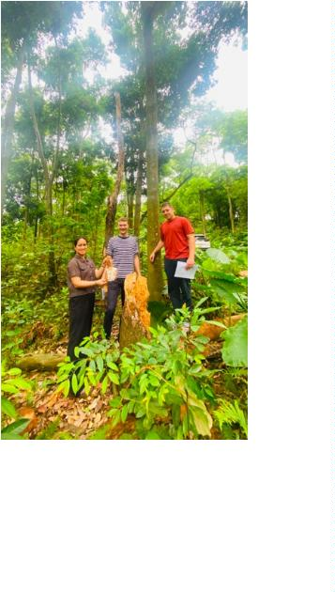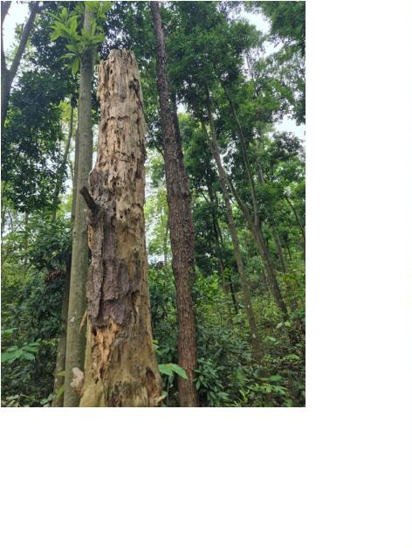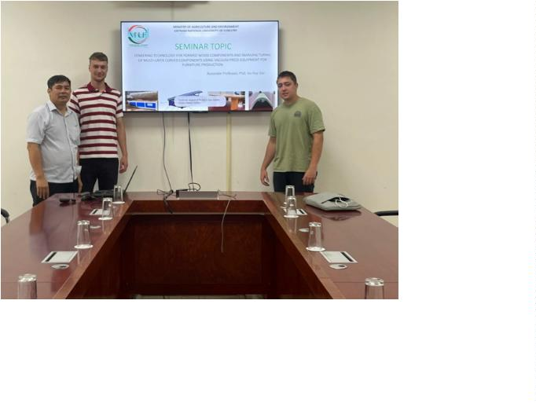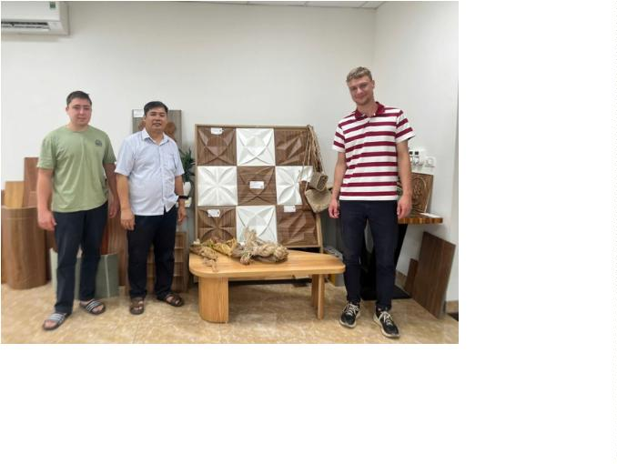

Furthermore, this imaging technique enabled us to document critical mechanical stress points
and structural anomalies within the samples, such as prominent radial cracking.
The smartphone's digital capture facilitated precise, real-time data collection of both
longitudinal and transverse structural variations. Ultimately, this hands-on wood anatomy
work demonstrated the viability of mobile optical tools in rigorous botanical analysis.
11. Field Observations of Local Manufacturing and Handicrafts - Dai Vu Huy
and Phuong Tong Thi
Field excursions to local processing facilities revealed the dynamic duality of Vietnam's wood
and bamboo industries, where advanced technology and traditional craftsmanship seamlessly
coexist. We observed primary log processing, automated CNC machining, and precision
cutting alongside highly skilled manual labor, including intricate wood carving and the hand-
painting of statues. Furthermore, visits to bamboo and rattan weaving workshops showcased
the intricate production of high-value handicrafts, such as woven baskets and lampshades.
This integration of modern mechanized production with heritage artisanal techniques
highlights the versatility, cultural richness, and economic resilience of the local manufacturing
sector.
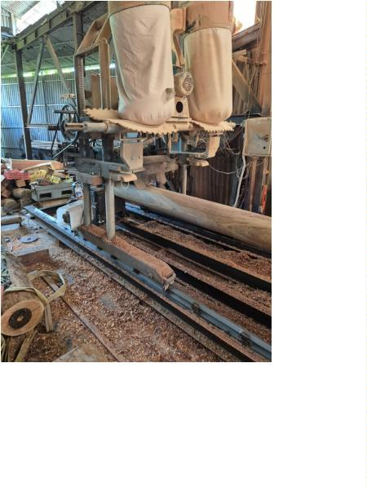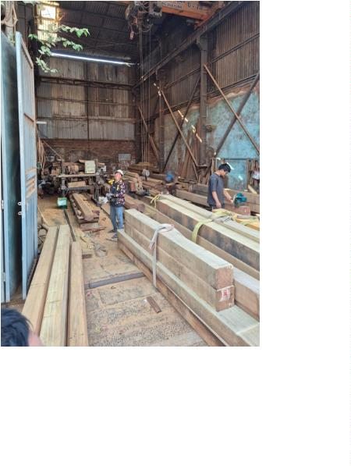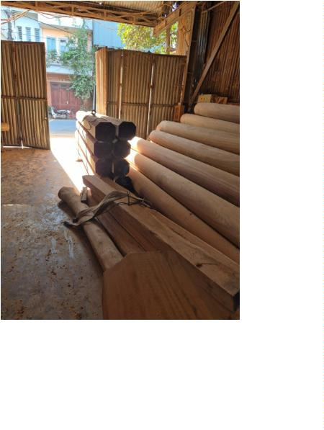

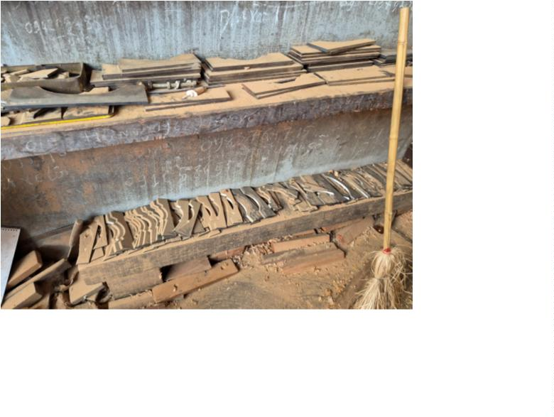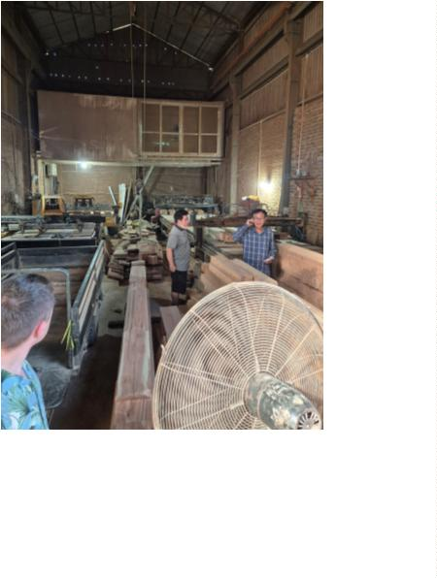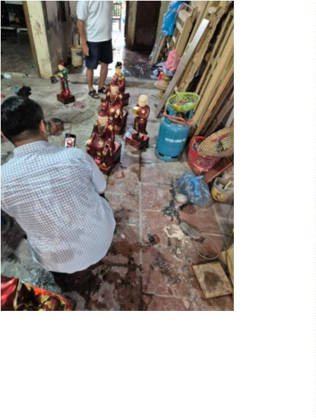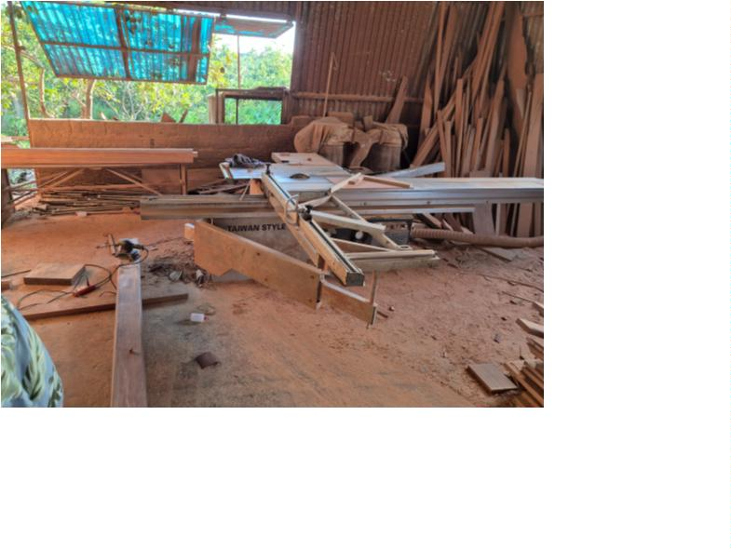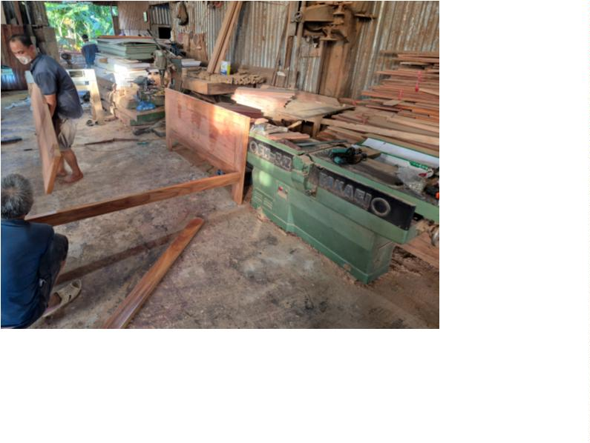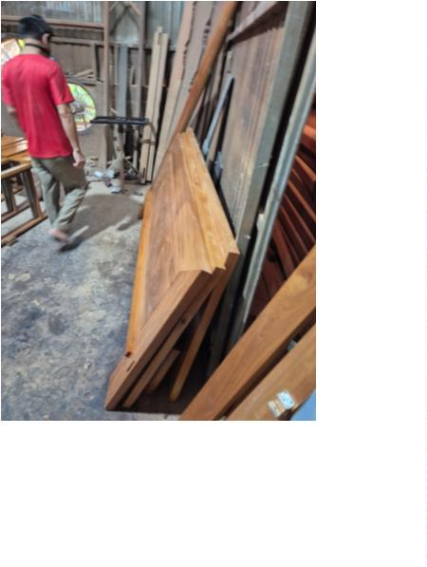

Conclusion
In conclusion, our month at VNUF was an amazing experience that went far beyond the
classroom. We had the chance to see the entire spectrum of the wood industry—from
examining wood anatomy under a smartphone microscope to understanding how Vietnamese
furniture reaches the global market. Witnessing the perfect mix of proud, traditional
craftsmanship and modern, sustainable technologies was truly inspiring. This program clearly
showed us that the future of the wood and furniture industry lies in respecting our natural
resources while boldly embracing new engineering solutions.
